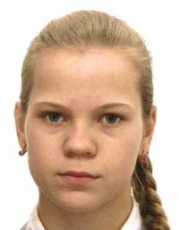 | GUZUN, Tatiana  Russia (RUS)  (Category -63 kg) | 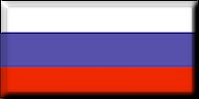

Successes: Bielsko-Biala Cadets European Cup 2018: 2. place, Tula Cadets European Cup 2018: 2. place, Follonica Cadets European Cup 2018: 3. place

Fights:
 | 1st Fight [-63 kg]: Preliminary round
 | 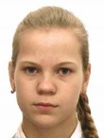 GUZUN Tatiana (Russia) | 1 0 - 0 1 1  I W P I W P  4:46 | STOLZE Friederike  (Germany)

 | 2nd Fight [-63 kg]: Preliminary round
 | GUZUN Tatiana  (Russia) | 1 0 - 0 0 1  I W P I W P  2:14 | VASILIAUSKAITE Aida  (Lithuania)

 | 3rd Fight [-63 kg]: Preliminary round
 | GAME Mollie  (Great Britain) | 0 0 3 1 1 1  I W P I W P  3:10 | GUZUN Tatiana  (Russia)

 | 4th Fight [-63 kg]: Semifinal
 | GUZUN Tatiana  (Russia) | 0 0 - 1 0 -  I W P I W P  0:33 | VISSER Marin  (Netherlands)

 | 5th Fight [-63 kg]: Fight for 3rd place
 | CORRAO Alessia  (Belgium) | 1 0 1 0 0 -  I W P I W P  3:05 | GUZUN Tatiana  (Russia)

Result: 5th place
Fights: 5
Total score: 3 x Ippon, 1 x Waza-ari, 0 x Yuko und 0 x Koka

